Damaged surfaces & cleaning

Damaged surfaces cannot be cleaned or disinfected effectively.

Damaged surfaces can include:

Painted surfaces which are worn or damaged, such as holes

Flooring that is broken/cracked, resulting in uneven and impaired surfaces

Old tape residue on drawers and doors

Torn covers on patient care equipment

Wood surfaces with worn finish

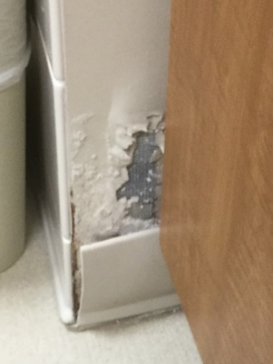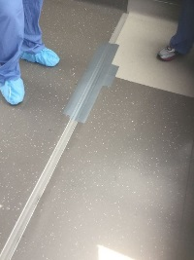
1
2

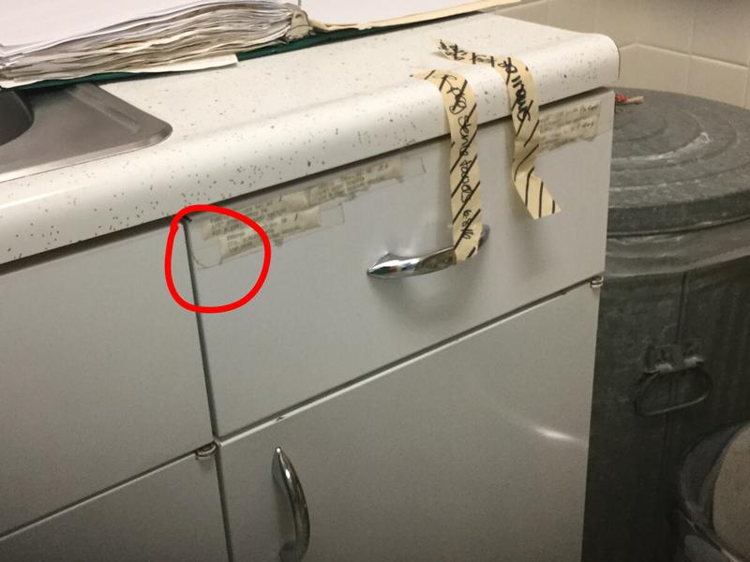
3

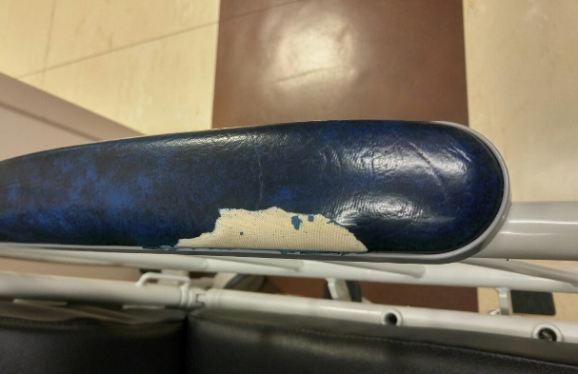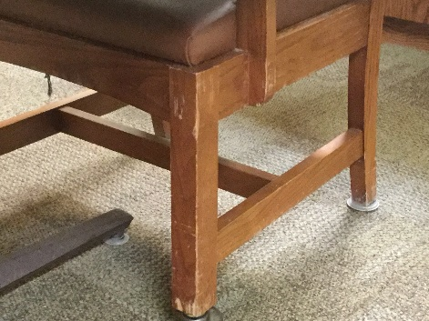
5
4

Please call (insert name here) to report worn surfaces – (list phone number)

