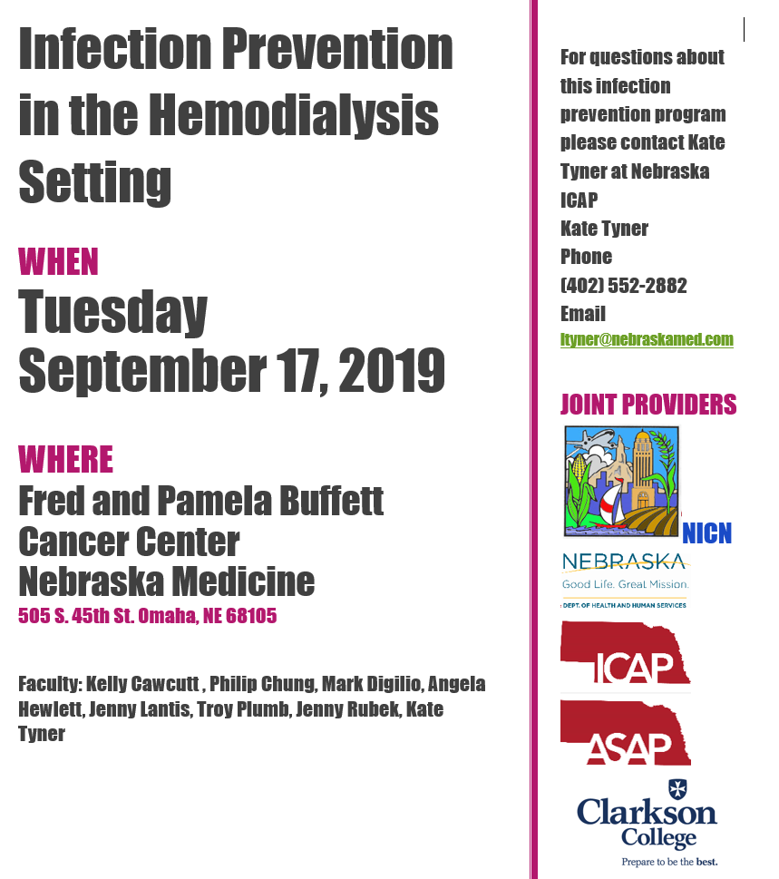

Faculty
Kelly Cawcutt, M.D., M.S.
Assistant Professor, Department of Internal Medicine; Associate Medical Director, Infection Control & Epidemiology; Co-Director, Digital Innovation and Social Media Strategy
Philip Chung, PharmD, MS, BCPS, BCIDP
Pharmacist coordinator of the Nebraska ASAP and co-pharmacist coordinator for the Nebraska Medicine Antimicrobial Stewardship Program
Mark Digilio
Director of Environmental Services for Nebraska Medicine
Angela Hewlett, M.D., M.S.
Associate Professor, Department Internal Medicine; Medical Director, Nebraska Biocontainment Unit; Associate Medical Director, Infection Control and Epidemiology
Jenny Lantis, RN, CIC
Infection Prevention Coordinator at Great Plains Health
Troy Plumb, M.D.
Dr. Dennis Ross Chair and Chief, Division of Nephrology; Associate Professor of Medicine, Fellowship Program Director
Jenny Rubek, RN, BSN, CIC
Infection Preventionist and Employee Health at Mary Lanning Healthcare
Kate Tyner, RN, BSN, CIC
Infection Prevention coordinator of the Nebraska ICAP and ASAP
Download the agenda here
REGISTRATION LINK HERE

