Email template/ideas for inpatient/ acute care IPs to investigate if dental units/ waterlines are a risk within their facility, especially perioperative areas.

Hi (consider targeting the OR Manager),
My name is ---- and I am an infection preventionist here at -----.
Recently, I became aware of the risks that are associated with dental unit water lines, especially regarding the maintenance and monitoring of dental waterlines.
While rare, there have been multiple documented cases of disease transmission from dental unit waterlines (narrow-bore plastic tubing that carry water to the high-speed handpiece, air/water syringe, and ultrasonic scaler). Dental units have unique characteristics that make them prone to biofilm formation. As a result, high numbers of common waterborne bacteria can be found in untreated dental unit water systems. Disease-causing microorganisms found in untreated dental unit water can include Legionella, Pseudomonas aeruginosa, and nontuberculous Mycobacteria (NTM).
For this reason, I am reaching out to ascertain if our facility has dental units. I’ve included examples in pictures below.
It is most likely that these units are used during dental procedures which include general dental hygiene (such as dental cleanings under sedation), restorative procedures (such as root canals, extractions, and fillings) and reconstructions.
Examples of dental units:
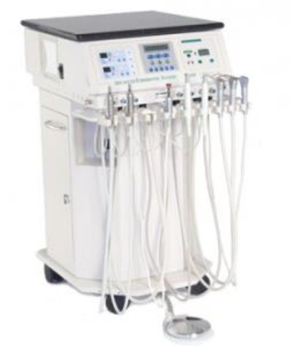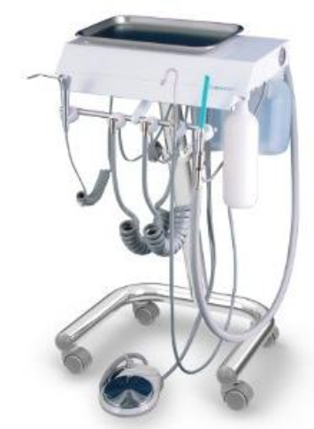
Does our facility utilize this equipment or provide OR access to dentists or oral surgeons for dental surgeries?
If yes, then I would like to meet with you to understand more about the use and maintenance procedures.
Thank you,

