**Hand Hygiene**

Hand hygiene is the most effective way to prevent the transmission of disease in the healthcare setting. For routine dental examinations and nonsurgical procedures, use an alcohol-based hand rub or use water and soap which is specific for health care settings. Always perform hand hygiene in the following situations:

* Before and after treating each patient

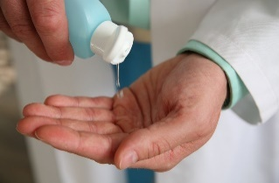

[This Photo](https://healthcare-in-europe.com/en/news/will-resistant-bacteria-be-the-end-of-alcohol-hand-sanitizers.html) by Unknown Author is licensed under [CC BY-SA](https://creativecommons.org/licenses/by-sa/3.0/)

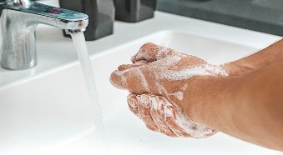

[This Photo](https://foto.wuestenigel.com/female-hands-washing-clothes-in-basin/) by Unknown Author is licensed under [CC BY](https://creativecommons.org/licenses/by/3.0/)

* Before leaving the dental treatment area
* Before gloving and after removing gloves and other PPE
* Before and after eating
* After using the restroom
* When hands are visibly soiled (soap and water)
* After accidental, bare handed touching of instruments, equipment, surfaces or other items that have not been appropriately decontaminated

**Using alcohol-based hand rub (ABHR) is preferred over soap and water unless hands are visibly soiled:**

* Dispense the recommended amount of product.
* Apply product to the palm of one hand.
* Rub hands together, making sure that all surfaces of hands and fingers are covered until they are dry, for about 20 seconds (no rinsing is required).

**Hand washing with soap and water is needed when hands are visibly soiled:**

* Wet hands first with warm water
* Apply soap to hands
* Rub hands vigorously for at least 20 seconds, covering all surfaces of hands and fingers
* Rinse hands with water and dry thoroughly with a paper towel
* Use a paper towel to turn off the water faucet.

Scan QR Code for

CDC Resources

Clean Hands Count

Clinical Safety

Clean Hands Count

Healthcare Training

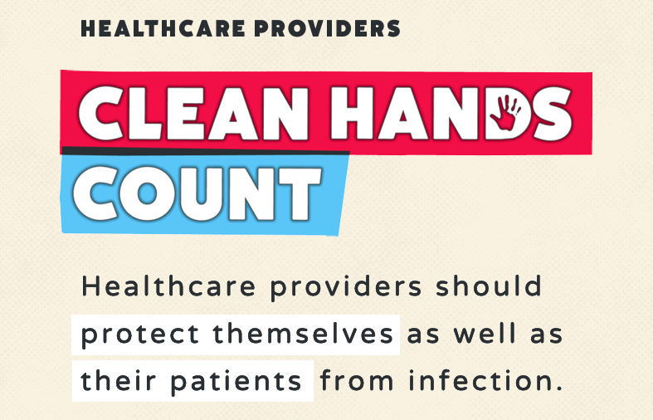



Centers for Disease Control and Prevention. 2024. Clean Hands Count: Clinical Safety. <https://www.cdc.gov/clean-hands/hcp/clinical-safety/index.html>

**Personal Protective Equipment (PPE)**

PPE are designed to protect dental health care providers from exposure to with infectious materials and should be worn anytime there is the potential to be exposed to splash, splatter, aerosols, other potentially infectious materials or chemical agents.

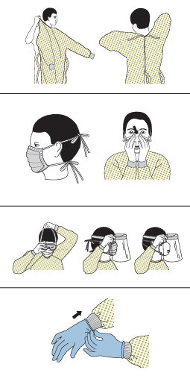

**Protective Clothing (Gowns, Lab Coats):**

* Should be worn anytime there is a potential for splash and splatter
* Should cover exposed skin
* Should be changed when visibly soiled by blood or other body fluids
* Should be removed before leaving the work area

**Masks:**

* Should be worn any time there is a potential for splash and splatter
* Should cover both the mouth and nose completely
* Should be changed between each patient encounter or when they become wet or soiled

**Eyewear:**

* Should be worn any time there is the potential for splash and splatter
* Should have solid side shields and be rated for chemical and impact resistance (ANSI Z87.1)
* Should be cleaned and disinfected when visibly soiled or removed
* Personal prescription eyewear is not a substitute for protective eyewear
* Protective eyewear of the same quality should also be provided to patients during care

**Gloves:**

* Should be worn when there is the possibility of touching mucous membranes, blood, saliva, or other potentially infectious materials

Scan QR Code for

CDC PPE Donning

And Doffing Sequence

* Gloves are for single patient use and should be discarded after patient care or when they are torn, cut or punctured
* Always perform hand hygiene immediately after glove removal
* Patient exam gloves are non-sterile gloves used for patient care, examinations, and other nonsurgical procedures
* Utility gloves are thick, puncture/ chemical resistant gloves for certain procedures such as cleaning, disinfecting, and handling contaminated sharps. They are not intended for use during patient care.

National Institute for Occupational Safety and Health (NIOSH). 2024 Directory of Personal Protective Equipment.<https://www.cdc.gov/niosh/ppe/default.html>

**Environmental Barrier Use**

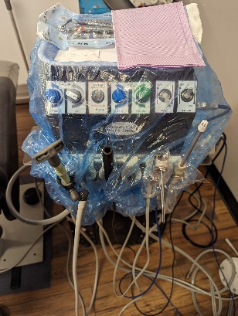Surface barriers should be used to cover any hard to clean clinical contact surfaces. New barriers should be placed during appointment set up (once surfaces have been cleaned and disinfected) and removed after the patient appointment is completed.

Hard to clean, clinical contact surfaces could include:

1. Patient chair/ head rest
2. Any countertop or surface that is being used for patient care
3. Control switches and buttons on dental unit
4. Hoses on dental unit, including A/W syringe, HVE suction, saliva ejector, handpiece hoses if used

Centers for Disease Control and Prevention.

2024. Best Practice for Environmental Infection

Prevention and Control. <https://www.cdc.gov/dental-infection-control/hcp/dental-ipc-faqs/cleaning-disinfecting-environmental-surface.html#cdc_generic_section_5-clinical-contact-surfaces>

**Cleaning and Disinfection of Clinical Contact Surfaces**

Emphasis for cleaning and disinfection should focus on surfaces that are most likely to become contaminated with pathogens, including clinical contact surfaces in the patient-care area.

* Once the treatment area has been identified, it should be cleaned and disinfected before set-up

Scan QR Code for

Ne ICAP EVS Videos

* PPE, including utility gloves and protective eyewear should be worn when using the chemical cleaner/ disinfectant
* After treatment for each patient, clinical surfaces should be cleaned/ disinfected
* Cleaning and disinfection is a 2-step process, first clean the surface to remove soil and then wipe the surface again to disinfect. Ensure the surface remains visibly wet for the contact time specified in the product instructions for use before the next setup.
* Equipment processes, like flushing waterlines and evacuation lines must also be completed to ensure there is no risk of cross contamination

Centers for Disease Control and Prevention. 2024. Environmental Cleaning in Healthcare Settings: Limited Resource Settings. <https://www.cdc.gov/healthcare-associated-infections/media/pdfs/environmental-cleaning-RLS-508.pdf>

**On-Site Contaminated Instrument Management and Transport**

In the public health setting, every effort should be made to use single-use, disposable items. When reusable patient items are used, they must be cleaned and sterilized to prevent transmission of disease between patients. Because of the nature of public health dentistry, contaminated instruments must be transported back to a central location to be terminally cleaned and sterilized.

**Things to remember:**

* Contaminated instruments should be safely transferred to an OSHA approved transport container during treatment area cleaning/ disinfection. This container should be leak/ puncture resistant, latchable/ lockable and have a biohazard label.
* Utility gloves should be worn during treatment area cleaning/ disinfection and handling contaminated instruments when packing for transport.

**Contaminated Instrument Preparation and Transport Process**

|  |  |
| --- | --- |
| Step 1: Don appropriate PPE. | Hu-Friedy 40-062 IMS Nitrile Lilac Utility Gloves Medium 8 Reusable 3/pk, Size: One Size |
| Step 2: After use and before instruments are placed in transport container, remove visible debris and saliva with a damp gauze. | Assisting during microsurgery ... |
| Step 3: Place pre-cleaned instruments in an approved transport container. If hinged instruments are present, leave them in the open position. |  |
| Step 4: Saturate instruments in transport container with enzymatic spray/ foam. Instruments must remain saturated with the enzymatic spray/ foam according to the product instructions for use and during transport. |  |
| Step 5: Individual instrument set transport containers should be placed in a single, larger, secondary transport container that also meets the above specifications before being placed in the vehicle for transport. |  |
| Step 6: Instruments can then be transported back to the location identified for cleaning and sterilization. |  |
| Step 7: Clean and disinfect transport containers after use*. |  |

*Sterile, packaged instruments should also be transported to community health settings in a rigid transport container that could be the same style, but should not be the same container that is used for contaminated instrument transport.

U.S. Department of Labor, Occupational Safety and Health Administration. 2024. Bloodborne Pathogens Standard. <https://www.osha.gov/laws-regs/regulations/standardnumber/1910/1910.1030>